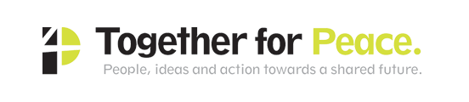
Job Application Pack for Project Administrator
Together for Peace is leading on Work Package 3 for the
Leeds Climate Emergency Community Action Programme
funded by the National Lottery Community Fund’s new Climate Action Fund

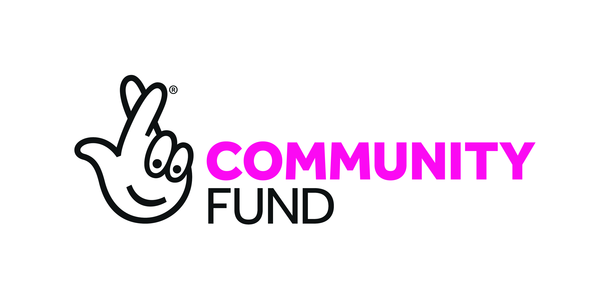

Job Title: Project Administrator
Hours: 18.5 per week – hours of work negotiable
Salary: £22,000 pa pro rata (£11,000)
Plus 4% pension contribution on total earnings (NEST)
Reporting to: Project Co-ordinator
Accountable to T4P climate action team
Contract: Fixed term until October 2025
For informal enquiries email Tony Herrmann hello@t4p.org.uk
To apply, please send the following documents only to - hello@t4p.org.uk
- Summary CV (max 2 pages A4)
- Application Form – see p5
- Contact details for 2 referees including email and telephone number
Closing Date 5pm Friday 23rd October - Interviews will be held on Monday 2nd November

Registered charity No. 1125153
Company Limited by Guarantee No. 06633741
Details for applicants
Together for Peace is a small, flexible organisation that brings people together from all sorts of backgrounds, from grassroots to government. We love questions that take us beyond our current thinking. We generate innovative and inclusive projects and events towards the common good.
*********
We are a partner with Our Future Leeds and many other organisations that were successful in gaining funding for this exciting new climate action project in Leeds. We are leading the Climate Action Hubs element of the project (Work Package 3).

Project Overview
This job is part of a new £2.5 million climate action programme of work in Leeds funded by the National Lottery Climate Action Fund. This work is being taken forward by a partnership made up of Voluntary Action Leeds, Our Future Leeds, Together for Peace and Leeds TIDAL. The overall aim of this work is to create a ‘zero-carbon, nature friendly, socially just Leeds by the 2030s’. Our aim is that further funding will be secured. (Read the press release here.)
The project has five ‘work packages’ that will work together over the five years of the fund:
- Management (Work Package 1): Voluntary Action Leeds will provide organisational and management support to the whole programme.
- Movement Building (Work Package 2): Our Future Leeds will lead programme development and strategic direction. This will include facilitating city-wide stakeholder dialogue, developing a city-wide Climate Justice Action Plan and a central Climate Action Hub, hosting Climate Assemblies and Roundtables, and providing a programme of training to be used in the community hubs.
- Community Hubs (Work Package 3): Together for Peace will develop and coordinate the network of community hubs and associated action plans through in-depth community engagement. The community hubs will work closely with the central city-centre hub
- Sector and Campaign Support (Work Package 4): Leeds Tidal will provide campaign and sector support and skills across issues such as housing, transport and food which directly support the community and central hubs, along with a cross cutting role on Climate Justice.
- Learning and Education (Work Package 5): A further partner (yet to be confirmed) will lead on learning and evaluation.
A key aspects for all post-holders employed on the programme will be integrated working and communication within - and between - the Work Packages. Therefore, post-holders will be expected to understand and support each other’s work in order to take forward a broader city-wide Climate Justice Plan, roundtables, assemblies and training and ensure programme plans are joined up, and guarantee learning is shared and celebrated to inspire others.

Further details of the Together for Peace led WP3 are in Appendix 1

Purpose of the job
The project administrator will operate as part of the team with T4P associates who are supporting four neighbourhoods initially increasing to eight after approximately 10 months.
Work will involve supporting the project coordinator and team to provide efficient and effective administration, communication and financial information and contribute to the smooth running of the team.

Together for Peace work is carried out by a team of associates operating with a flat collaborative structure. The T4P team is currently composed of a majority of white people and we are increasingly aware of the limitations and problems that this brings about within our work and within our wider society. We recognise the need and the value, both within the T4P team and in relation to the communities we are working with, for people from other backgrounds and heritages.
We therefore strongly encourage applications from people of South Asian, South East Asian and East Asian heritage, people of African or Caribbean heritage, people of Latin American heritage, and anybody else who experiences racism

Key areas of responsibility are
- Managing internal and external communications to support the team
- Establishing and managing the team’s contacts system
- Inputting financial data to the T4P finance system (QuickBooks Online) and providing reports as required
- Keeping accurate records of team activities and progress in neighbourhoods provided by team members on a project management system
- Providing administrative support to team members as required
- Supporting the coordinator with data required by the project reporting system
- Liaising with other stakeholders both within and external to the overall CECAP project
- Any other tasks that are reasonably required
Person Spec
    - A good understanding of, and skills in all areas of administration including communications, finance and data systems.
    - At least three years employment track record of successful administration and/or project support.
    - Experience of directly operating a range of software programmes and systems including spreadsheets, databases and finance management software
    - A knowledge and experience of contact management systems would be an advantage
    - Experience and an ability to work effectively with social media
    - An ability to focus on the detail
    - A pro-active, positive and enthusiastic approach
    - Excellent written and verbal communication skills
    - The ability to organise yourself, working responsibly at all times and meet deadlines
    - The ability to work effectively as part of a team

Application Form
Please use the following 2 pages to show the knowledge, skills and experience you bring to this role, and how you would put them into practice to achieve the desired outcomes

Appendix 1
Extracts from Bid Document - Project summary
We devised five work packages in order to meet our overall programme aim of far reaching and transformative community-led climate action. We know that significant climate action needs to be taken at a community level, across transport, goods and services, food and waste, as well as individual and household level changes in consumption and lifestyle. Each community will determine the pace and depth of their actions, informed and motivated by our climate emergency literacy, skills and training and supported by existing research and analysis. Many local community changes will be underpinned and strengthened by successful sector and campaign groups and city-wide cooperation and coordination.

We want to avoid community-led action that happens in isolation or isn't focused on the scale of the challenge. That's why our programme is created around city-wide connections between community hubs, and a broader package of training and support on the nature and scale of change. In this way we want to link benefits across activities and tackle city wide as well as local issues. What we know is that many community concerns cannot be addressed at a local level but require city-wide (or even national) campaigns and action. The change we want to see brings together the lived experience and local knowledge of communities with city, national and sector perspectives, skills and capabilities. In this way community climate action plans will be co-produced across our 16 hubs by multisector teams that have the potential to be genuinely transformative.

Once the framework of linked community and city wide action has been developed, tested and refined over the five years of the project, it will be ready for scaling up to reach across the city as a whole.

b. Project plan: Our Work Packages

Below we outline our five work packages, outlining the change that we aim to achieve, expected milestones, outcomes and outputs. The diagram below summarises the relationship between the five work packages.

How the work packages work together to support community-led climate action

WP3 supports changes in the local community by co-producing a community-owned climate action plan and crystallising activities around community action hubs as spaces to meet, learn, exchange, discuss, plan and act. WP4 supports thematic actions and changes by communities of interest that span across and beyond communities of place, empowering communities to realise their needs and interests in matters that are usually beyond their control, and by providing in depth expertise where it is needed. WP2 informs, supports and connects these communities and their climate actions through training, research, analysis and specific support, carries them into city-wide stakeholder dialogues, and integrates them into a city-wide vision and plan for change - one that matches the scale and nature of the challenge while being firmly rooted in community needs, concerns and interests.
WP 2,3 and 4 are vitally supported by WP5 for monitoring, evaluating and increasing learning and WP1 project administration and delivery.

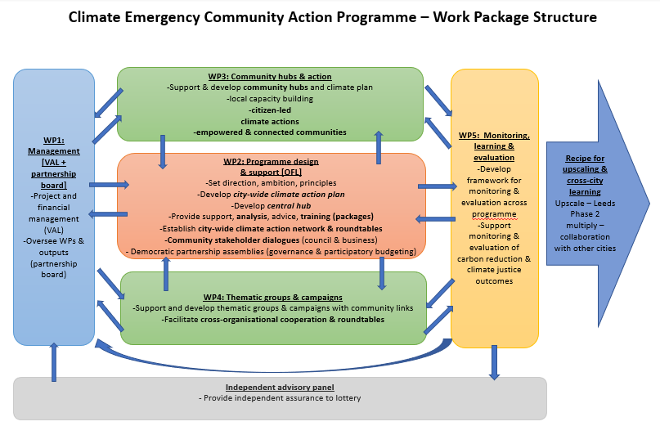

Figure 3: Programme work package structure

Work package 1 - Management (Voluntary Action Leeds)

As grant lead, Voluntary Action Leeds will cover the following key roles:
Management of Delivery Structure

VAL will have a supportive delivery framework in achieving the overall objectives of the programme, taking overall responsibility for performance and financial management. This will be delivered through a Coordinator, Support packages, and Administration time.

This will include communications and support for governance via the Board, and the active involvement of agencies and partners within the programme, in Roundtable events, and co-production.

Accountable for agreed outcomes/outputs

A reporting system will be put in place, to provide a systematic collation of evidence and outputs, against the programme deliverables, funding allocations, and work programmes agreed by the Board.

Performance Management

Objectives to be achieved will be established by the Board in dialogue with the National Lottery, and will bring together activities and learning at neighbourhood level, along with the broader objectives of measuring progress at city-wide level on the city carbon budget, and the activities which go into carbon production. The reporting system will collect evidence from partners, and will be used to shape the ongoing and future learning from the programme.

Finance Management/Payments

A finance structure will be in place (which will mirror that provided for Big Local projects), to enable payments to partners against the agreed work programme.

Impact reporting and measurement

It is anticipated that impact will be at all levels from individual awareness, to community activity, to broader city-wide change to the carbon budget. Reporting mechanisms will be in place to capture activity, knowledge and ownership of the consequences of climate change, and emissions.

Up and down communication/reporting

Communication will be the significant factor in the success of the Programme. Voluntary Action Leeds in conjunction with Our Future Leeds through the assemblies and city wide roundtables will take responsibility for communicating between partners, bringing them together, keeping them informed of progress.

Programme Promotion and Comms

Programme-specific web communications will be used, alongside wide use of social media (Twitter, a Facebook page, email communications) to share the overall programme with a wider audience, from communities, to statutory authorities to media. VAL will work with OFL, Tidal and T4P to ensure communications for stakeholders within the programme are coordinated between partners.
*******************************************
Work package 2 - Programme Design and support (Our Future Leeds)

Our Future Leeds will take overall responsibility for setting the scene, ambition, direction and project values. OFL are playing this role as a backbone movement organisation, spanning and connecting diverse sectors in Leeds across community, campaign, research, local authority and business communities. The WP brings together work over the last year to create a citizen-led movement that can support and organise meaningful activity in the light of the climate emergency. This WP is at the heart of the project and will inform and support the work of the others. OFL staff will support the design and direction of the overall programme of work. WP2 is organised into five strands of work.

1. Climate emergency training

2. A central climate emergency hub, will be hosted in a city centre location.

3. Democratic and cross programme decision making and networking will be hosted via Assemblies and the Roundtable
4. Stakeholder engagement will enable the latest information on climate science, local authority and national policy and specialist sector knowledge to support our community-led process.

5. A city-wide Climate Action Plan will draw on the latest evidence, community engagement within Leeds, community-led plans being developed in other localities (e.g. Bristol, Manchester, Cambridge) and represent a state of the art snapshot of the climate, nature and social challenges and what communities and the city as a whole can do to respond to these. It will incorporate learning and contributions from across the whole programme’s activities.

Deliverables: 20 x Quarterly assemblies, 10 x bi-annual roundtables, 1 x Climate Action Plan, 1 city-wide Climate Emergency Hub, Climate Trainings (number to be determined).

Outputs: by the end of this project we would like to see a regular well run city roundtable with over 200 people actively participating on a regular basis. We want Our Future Leeds to be a buzzing community of over 10,000 people from diverse communities and backgrounds across the whole city.

Outcomes: a connected and informed city-wide network that supports community-led action to take effective climate action.

*******************************************

Work package 3 - Community Action Hubs and Plans (Together for Peace)

This project aims to engage people and community organisations in at least 16 neighbourhoods in Leeds in plans, projects, activities and behaviour change that will reduce carbon emissions. By the end of the project we would envisage large numbers of the population of Leeds being actively involved in tackling the Climate Emergency through a network of community led and based climate action hubs in their ‘patch’, inspired by this work. There are three levels of engagement:

Level 1. 8 Climate Action Hubs

The project will work intensively in 8 neighbourhoods selected from a set of 6 archetypes to ensure we address a range of different areas in terms of income, housing, levels of individual carbon footprints and current levels of involvement in tackling the climate emergency.

In these 8 areas we will carry out a thorough, skilled and sensitive developmental process to ensure that the resulting hub is genuinely community-led and owned, whilst still being part of the city-wide process this bid represents. Staff from the programme working in each area will have excellent skills in community work, partnership building and the art of holding difficult conversations and will go through a process of scoping assets, organisations and contacts, network and partnership building followed by establishing a climate action group to develop plans for the hub. Once the hub is established the programme will provide a local worker for the hub plus direct cost support with the development worker offering light touch support over 3 years. Support will start to phase out towards the end of the 3 years to cushion the transition to sustainable operation. Clear links will be made between neighbourhood hubs and other elements of the programme offering climate science, cross cutting themed partnerships and democratic decision forums.

The 8 selected areas will all be supported to develop key outputs of a Climate Emergency Community Action Hub and a Climate Emergency Plan. They will be phased with work starting in 4 areas in Year 1 and the second phase of 4 starting approximately 10 months later. Each area will be supported through an estimated timetable of:

- 2 months – scoping and negotiating the project details with local groups and leaders
- 3 months – network and partnership building
- 3 months – working with a Steering group to develop plans for the Hub
- This will be followed by 3 years of Hub operation.
The exact timetable for each community will need to have some flexibility to respond to the local context.

In phase 1, project staff will work alongside the groups identified in the 4 areas of Seacroft, Beeston, Garforth and Otley to identify and engage further community-led groups and organisations within the community who can contribute to the project and contact community leaders who can help to bring people from the wider community together. A period of partnership and network building will then lead towards the formation of a steering group for the project in that neighbourhood. Where possible, we will work through close collaboration with an existing local organisation that is community based and led. The steering group will then develop ideas and test feasibility of opening a local Hub. The concept of a Hub will incorporate both a base for activities and the core group of people involved. Wherever possible there will be a physical space open for regular periods of time every week. In addition, the steering group will start to consider how they can develop a Plan for the area that addresses both carbon reduction activities and behaviour change that will lead to reductions.

Support for developing a Plan will be drawn from the wide range of people and organisations involved in Our Future Leeds and this whole programme so that expertise can be applied to ensure the Plan is accurate, feasible and addresses the key issues needed to tackle the climate emergency.

Wherever possible we will establish cross cutting links between this part of the programme and other areas developing theme based and city wide partnerships and actions. For example a schools network will help to link local schools with a local Hub. Or a Hub working on transport issues can link with city-wide transport plans and expertise.

The local Hubs will work to:

❖ Produce a Climate Emergency Action Plan for the area
❖ Facilitate real carbon reduction activities by people and organisations
❖ Encourage and enable local people to change behaviour and become active in tackling the emergency in a variety of ways
❖ Understand and incorporate social, economic and racial justice actions within a climate justice framework
❖ Provide a physical base to attract people in, focus resources and information
When there is a clear and feasible plan for the Hub, the local steering group will become the core group of people, taking responsibility for developing and then managing the hub, and participating in the OFL city wide network and funded project.
Once the hub is running, a local p/t worker (0.4 FTE) will be appointed to support the group and assist in managing the Hub and local activities for a period of 3 years, together with light touch support from the development worker (0.2 FTE). Each hub will also have financial grants of at least £8,000 per year for direct running costs for 3 years. Some financial and development worker support will be available towards the end of the programme at a lower level and tapering off to help smooth the transition to a more volunteer run and sustainable model.
Each community is (to some extent) likely to require a unique approach. We will be as flexible as possible within the budget, guided by working collaboratively to ensure the development is genuinely community led and owned.
Level 2. 8 Mini Hubs
We will identify a further 8 areas for potential Mini Hubs. The areas will also be drawn from the range of archetypes but will focus on areas where there is some community infrastructure already. This may be a local climate action group, or a local community organisation that has ambitions to tackle the climate emergency. Support may vary according to the areas needs but will average 20 days of development staff support and some funding averaging £1,000 per area. It is anticipated that work in each area may be quite different. Some may have an active group and require climate science support to work on producing a Plan. Others may focus initially on the development process of drawing people together to form a climate action group. Some areas may wish to establish a specific project around a key issue of carbon reduction in the area rather than an overall plan.
As with the main Hubs, there will be an emphasis on forming a core group of people to drive the action, and that can become involved with other aspects of the programme and Our Future Leeds. In each area the activity will be focused to ensure there is a clear concept of a local hub and action plan.

It is anticipated that we will work with 2 areas in Year 2, and 3 in each of years 3 and 4.

Level 3. Responsive support

Further support to a range of initiatives from all across the city will be available from a funding pot that will offer both development support and financial grants. Some of this money will be distributed using a participatory budgeting approach.

This funding will be available to support actions, activities and projects from all areas of the city within the programme criteria of working towards carbon reduction, behaviour change and actions to tackle the climate emergency. For instance, a group of parents may be inspired to organise a pop-up hub at their local school in a different community, after visiting one the neighbourhood hubs. This group would be eligible for responsive support as well as support from the Education Worker (see Work Package 4).

Starting in Year 2, we will develop mechanisms to make this funding as accessible and focused as possible. Small grants will be easily and quickly distributed, whilst larger amounts will go to the OFL Climate Assembly for decisions. An element of the pot will be distributed through a participatory budgeting event (or events) that will bring increased energy and publicity to the grant programme, as well as ensuring decisions on this money is also community led. A total of £150,000 is allocated to this grant programme but it is divided into a budget of £60,000 to support specific projects within Hub and mini hub areas with £90,000 reserved for other areas in Leeds. This split will be reviewed annually starting at the end of year 2.

Outputs:

● 8 main climate action groups established in identified neighbourhoods
○ 8 main community hubs established and active
○ 8 associated community climate action plans.
● 8 groups supported to develop mini hubs in identified neighbourhoods
○ 8 plans agreed and projects undertaken
● At least 30 further community led climate action initiatives given responsive support funding

Outcomes:

● Each community hub coordinating and supporting a range of activities to reduce carbon emissions and achieve the targets in their action plan, with a sustainability plan in operation.
● Increased participation by under-represented groups and communities in local climate action,
● Increased participation by under-represented groups and communities in city wide climate action through Our Future Leeds - both to reduce carbon emissions and influence city wide policy and decision making to meet climate emergency goals.

By the end of this project we aim to have a sustainable network of community-based climate action, linked across the city and with city wide climate action initiatives. This will be supported by people from all groups and communities in Leeds, participating in myriad ways to transform the city into becoming a sustainable and just zero carbon city by 2030.
*******************************************
Work package 4 - Thematic groups and campaigns group support (Leeds Tidal)

The overall objective of this work package is to support and develop thematic groups, which provide education and training resources and support for community-led action across all neighbourhood hubs.

We’ve identified 8 key transition themes where we intend to organise and build community power, in order to achieve our bold vision:

1. Transport
2. Energy
3. Housing
4. Food
5. Nature
6. Climate Justice
7. Economy
8. Education

Each transition theme will have its own worker, contracted for 2 days a week for a 52 month contract (4 years and 4 months). There will also be a work package manager employed for a 56 month contract (4 years and 8 months).
Work Package 4 Management Responsibilities
Leeds Tidal will coordinate the work package and manage the team of workers. This role is imperative for consolidating and disseminating learning, and bringing about a joined up city-wide movement. The work package manager will be responsible for:
● Collaboratively developing a work package strategy and budget
● Recruiting eight workers for each transition theme
● Inducting workers on the Movement DNA (principles, strategy & structure)
● Establishing relationships, partnership agreements and worker contracts
● Management and supervision of workers
● Providing bespoke campaign development workshops as and when required, and ensuring the Movement DNA is embedded in all trainings
● Supporting workers to develop training, materials and engaging events for neighbourhood and city centre hubs
● Reporting and monitoring on the progress of the work package, and feeding this into Partnership Board meetings and to evaluation teams
● Seeking additional funding for the work package as and when required
● Other activities as appropriate to the needs of each thematic worker, such as supporting them to build capacity and resources for the campaigns and projects involved.

Work Package 4 Outcomes
The outcomes of this process will be community climate action on the different transition themes listed above. What this looks like for each thematic group will be determined by the communities of interest involved in creating their transition roadmaps, as well as the communities actioning them at the local level. The following table details some possible outcomes that would be achieved:
*******************************************
Work package 5 - Learning, monitoring and evaluation (WP lead to be appointed)
We are looking for an established and experienced organisation to be the programme’s Learning Partner and coordinate learning, monitoring and evaluation across the whole project. This is an important cross-cutting aspect of the project which evaluates and shares learning across all partners and communities as well as with other groups nationally who want to exchange and learn with us. They will already have experience in learning and evaluating activities in the community sector, and will be able to put clear systems in place for capturing and feeding back learning. They will be experienced at data handling and management in a safe way, and are likely to be skilled at developing creative and accessible methods of capturing qualitative information as well as hard data across a range of issues, sectors, and locations. They may bring in others to support this work as appropriate and will work closely with Our Future Leeds, especially in terms of developing shared aims, values and working practices. A significant part of this WP is creating a framework so we can monitor and show actual social justice and carbon saving benefits. We anticipate that clusters of researchers at the city’s universities will also be contracted with them to support some of these aspects.
The partner will co-create, together with the Partnership Board, a work programme to deliver the objectives of this work package in coherence with the overall partnership project. Tasks are likely to include:

● Developing/agreeing a framework for carbon monitoring at a neighbourhood level (potentially in conjunction with academic and National Lottery partners)
● Creating a monitoring framework for capturing the broader benefits and impacts of community-led activity on individuals and the wider community (e.g. social justice, health)
● Hosting community learning workshops using appropriate styles and approaches to capture learning as the programme proceeds
● Arranging external learning visits
● Creating a learning report that enables early learning that can inform subsequent phases of the project
● Creating a learning report that is accessible to all and enables wide community ownership of the programme impact and future development.
● Organising a Leeds climate action convention to showcase learning
● Consolidate actions for upscaling and next steps

WP5 Outputs
● Framework for carbon monitoring
● Framework for monitoring additional benefits
● Series of short summary reports to support development of test and learn areas
● Short annual learning report
● End of project report
● Workshops and creative engagement activities
● Verbal reports to Partnership Board and Assembly

WP5 Outcomes
● Communities and project partners better understand the carbon impacts of their project choices and actions.
● Communities and project partners better understand the additional benefits of their project choices and actions.
● Communities and project partners better understand how to engage communities in climate action.

