Climate Action Seacroft - Initial Year 1 Plan (August 2021)

SUMMARY
In the process of developing the plan we have three summary diagrams, capturing our priorities, structure/personnel & vision.
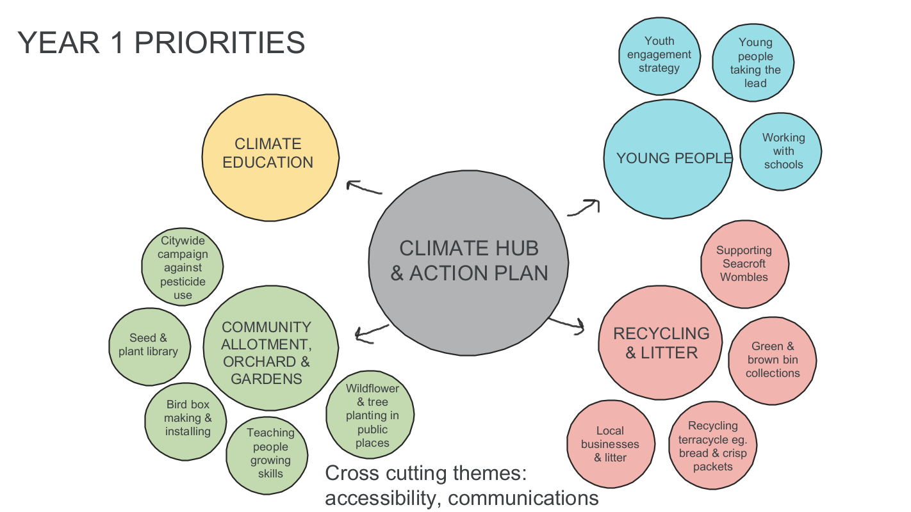

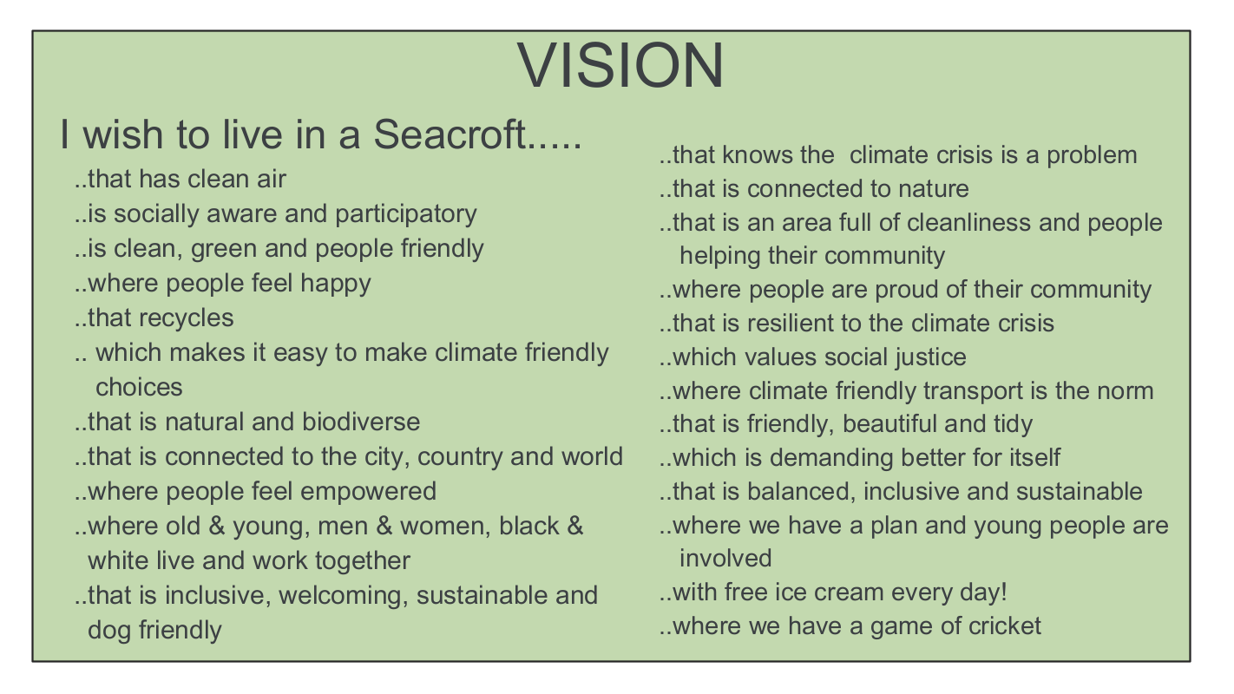

STRUCTURE

Steering group
The hub worker’s tasks will be overseen by a Steering Group comprising:
- 5 local residents: Katie Dye (Labour ward councillor), Gaynor Edwards, Dominic Moghal, Linda Otley, Clarrie Ramsden
- Sue Hoey (T4P)
- Chris Jackson (LS14 Trust)
They will meet bi-monthly to discuss the project & provide support & direction to the worker (more frequently if required). The Steering Group has responsibility for supporting the delivery of the Climate Action Plan & working to ensure the development of the hub.
Currently individuals have voluntarily stepped forward themselves for the Steering Group to support the initiative in these early stages. Moving forward we will aim to appoint the Steering Group on an annual basis, through a process whereby people can be nominated & agreed & based on individuals’ capacity. However, at this stage these were the only five volunteers from the core group of 15 or so.

Wider involvement
Other local residents are involved in the project who are not Steering Group members. They will influence & shape the direction of the project & get involved in particular activities that interest them. It is this group who have determined the focus for Year 1 and will do the same for subsequent years - with hopefully more people becoming involved over the duration of the project. This cohort of people is Climate Action Seacroft.
Around 25 local people have already had contact with the project, as well as several others from organisations working in the area. It is anticipated that this number will grow as different parts of the initiative develop, the hub starts to take shape & money can be spent on activities to promote the project.
People are welcome to be involved in the project on their own terms - for some this will be an occasional trip to the growing site, for others this will be much more frequent involvement in the overall strategy & direction of the project.
Over time a wider forum is likely to develop to include people who work in the area, in the local voluntary, education & statutory sectors.

Employment of Climate Action Seacroft worker
LS14 Trust will be the employing organisation for the Climate Action Seacroft worker, overseeing their employment, managing all the financial transactions for Climate Action Seacroft and providing a base for the worker. LS14 Trust is a local community organisation based in a row of shops on Kentmere Avenue, located between Kentmere Community Centre & St Richard’s Church, over the road from the top end of Rein Park. Established in 2009 by local residents it now has a 1,000 strong membership base. For more information about LS14 Trust click here: http://www.ls14trust.org/about-us1.html
LS14 Trust is a registered charitable company with five Trustees, ten employees and an income of £256,500 March 2019-20. It’s core charitable purpose is: ‘to develop the capacity and skills of the members of the socially & economically disadvantaged community of LS14 (Seacroft, Swarcliffe & Whinmoor) in such a way that they are better able to identify, and help meet, their needs & to participate more fully in society.’
Recruitment for the Climate Action Seacroft worker will begin over the summer, with the aim of a mid-September deadline for applications. Shortlisting is likely to take place w/c 20th September with interviews the following week, with a view to having a worker in place by the beginning of November.

INITIAL YEAR ONE PLAN

The initial Year One Plan captures contributions from 18 local Seacroft residents who have fed into its development and was ratified on Monday 26th July 2021 and will be reviewed termly over the next year by the Steering Group.

Climate Action Seacroft has already begun its activities.
‘Sunflowers for Seacroft’ was our first project, which distributed over 1600 packets of sunflower seeds via locations throughout the community, including schools, shops, doctors, library, village hall & local community centres. 600 were distributed by ‘The Good Gym’, who promote fitness through physical activity to help the community. This contact came to us from Zero Waste Leeds. The packets promoted Climate Action Seacroft & were a way to bring some colour & hope into the community. Local groups planted them with their participants, such as Zest’s Men’s Group.
In July we started work on Killingbeck Community Allotment. This is a community allotment site with a polytunnel, compost loo, tool shed & tools & pizza oven. The site had been created & developed previously as part of a Primrose Valley Community Project who also designed & established a local community orchard. The site had become very overgrown & unused during Covid - and perhaps also because funding for the part time project worker had run out - and they have welcomed our involvement. Our group has taken it over & is restoring it, as a place where we can get growing together this year. Most of the work has been done by people in our group & their friends, but we also had one participant who came with his Touchstone support worker & our hope is this sort of connection will develop.
The four core areas that participants have decided to focus on over this first year are:
- Engaging with young people
- Climate education across the whole community
- Recycling and waste
- Developing a community growing project
These cover 3 of the Climate Action Leeds transition themes: Education & young people, Food & Nature.
Varying numbers of people are involved in each area, with people engaging in the area(s) that interests them most. Currently much of the work is exploratory to see how we can build on activities already taking place locally.

1. Engaging with children & young people
Context
We are exploring working with local primary & secondary schools & have already distributed sunflower seeds to several of them, through our inaugural project: ‘Sunflowers for Seacroft’.
Leeds East Academy recently won a national Parliamentary Award for Sustainability and we have met with their climate action lead, Sarah Steele, to begin to develop a relationship with them & how we might support their activities. They already have a Zero Waste shop run by students stocking products made by students using waste materials. They are keen to get involved in the planned forest garden (see below). Natalie Quatermass (one of our group) has begun working with them to create 'Suitcase Stories', micro performances that look at the lived experience of the climate crisis from people all over the world.
Bishop Young Academy are working with a veterans charity to plant 10,000 trees on their school grounds.
John Tudor & Natalie (Seacroft Wombles) recently led a session on the climate with a local cub group. Natalie is also running a week-long Creative Camp in Seacroft for LS14 Trust during August. Some of the activities she is planning will be climate focused and includes a walk to the Killingbeck allotment & pizzas made in the outdoor oven there.

Climate Action Seacroft: Schools project launching during The Great Big Green Week 18th - 25th September 2021
Transition theme: Education & young people
This project will work with local primary schools, aimed at Key Stage 2. Participating local schools will invite children to come up with a simple, achievable, low-cost climate related action that could be taken within school - by a specific group (such as the children themselves or their parents) or implemented by the school.
Two people from Climate Action Seacroft will join two members of the teaching staff for the school in assessing the ideas & deciding on a winner, who will be announced at the beginning of November during COP26.
Climate Action Seacroft is exploring offering very small grants as matched funding to participating schools, as an incentive for engagement & to support the activity.
From this project, a small bank of ideas will be produced by the schools, which can be collated & shared around the cluster & more widely, to raise awareness of small climate related actions that can take place within schools.

2. Climate education across the whole community
Context
There is climate related work taking place amongst several of the local organisations in Seacroft, examples include:
- LS14 Trust young leaders programme - supporting young people in community action (includes climate)
- Chapel FM - Natalie is collaborating with them to create 'Taking Rubbish' a podcast which captures the stories of 'The Wombles.' They are currently running a youth climate course & participants have interviewed three members of our group & broadcasts are being made as part of the youth Red Kite radio show. A show called Think Global Act Local is also in production, which has interviewed Paul Chatterton, Helen Hayden & others. The pilot episode is being broadcast in September & will move to a monthly show if it’s successful.
Chris Jackson at LS14 Trust also works for the Development Education Centre (Youth & Education Transition Partner). He & Katie Dye (one of our group) are exploring running a cross-sector pilot of DEC’s new online climate education webinar. There are several local organisations & public sector employees keen to get involved & we will recruit Climate Action Seacroft members as well as other local residents to take part. There is no fixed timescale but the hope is for the pilot to take place in the autumn. The aim is for this to empower all who participate to integrate climate conversations into their day to day (working) lives. The webinar can then be utilised in other hubs & elsewhere in the city.
Two of our group attended training through Opera North, run by a Carbon Literacy trainer who founded Sustainable Arts in Leeds (SAIL). They highly recommend it & we will encourage others to attend as & when it becomes available again. This may require bursaries to cover the costs of participation for some.

Climate Action Seacroft: Seacroft climate campaign - raising awareness
Transition theme: Education
This is a longer term initiative to identify a single clear message that is locality appropriate that will encourage people to engage with one climate related issue.
It will require us to develop a brief & work with a (local) researcher to understand the current context regarding climate literacy in Seacroft, through a series of conversations with local people. We will use data from wider sources such as the new Place based carbon calculator produced by CREDS at Leeds University to inform which activities may achieve the most in terms of a reduction of carbon emissions within this ward.
From this we will work with a collective of people with expertise, alongside Climate Action Seacroft members, to develop a simple message that can be promoted widely.
Our current thinking is that it needs to be one, simple, clear concept that can be promoted over & over. Examples include: ‘5 a day’ or ‘Couch to 5k’.

3. Recycling & waste
Context
Early this year John Tudor (part of our group) set up Seacroft Wombles. Within 8 weeks the group had 150 members (currently 240) & it is fair to say he has catalysed a litter picking movement across Seacroft. Many individuals are going out separately & collectively to litter pick their streets, the many local green spaces & key public areas, such as by the shops. Several of our group are keen Womblers.
One local parent has been working with her school to encourage parents to recycle their glass bottles. Each time a bottle bank is filled, Ardagh Glass, the company who recycle the bottles, donate £1,000 to the school (Parklands Junior School) which they are spending on books for the library. Zero Waste Leeds & Seagulls are running a joint initiative during the summer holidays to engage children to design a mural which will be painted on the recycling banks outside the LS14 Trust building, in the hope that this will engage more residents in recycling.
This is also prompting conversations about how local businesses, in particular takeaways, could be supported to reduce their packaging or convert to eco friendly options. There is the potential for this to develop into a local campaign.
Other people connected to our group are interested in other aspects of recycling, such as ensuring doorstep recycling & garden waste services are available & exploring local recycling facilities.
Over the coming year we will explore how Climate Action Seacroft might work with residents & existing initiatives to support & expand these initiatives.

4. Developing a community growing project
Context
There are 101 council allotment sites in Leeds, only 3 of which are in Seacroft. Between them these three have a total of 48 individual allotment plots. We connected with two members of our group through the LCC allotment waiting lists in the area. Two members of our group have many years experience of growing, others have begun growing vegetables in their gardens during Covid. We have also found others keen to join this particular aspect of Climate Action Seacroft as a way to get to know people in the community, be outdoors & learn some new skills. Many houses in Seacroft have large gardens, so learning how to grow edibles is something with lots of potential - we have already had the idea of a ‘people library’, to run a bit like a very simple LETS scheme, so that people with skills can support people who want to learn.

Climate Action Seacroft: Growing Together
Over time the growing project is becoming an umbrella for several initiatives, including:
- A community allotment site
- A community forest garden
- Wildflower spaces & a ‘no mow’ approach
- Seed & plant libraries
- Satellite gardens throughout the community

Seacroft community growing site
Transition theme: Food
Alongside the modest plot at Killingbeck, we are exploring sites on which to develop a community growing project. The most promising for this is land located between the LS14 Trust building on Kentmere Avenue and the Kentmere Community Centre. This site used to be home to the Gate pub & is currently owned by LCC Housing. When the building was demolished, the area was grassed over at the request of LS14 Trust with a view to it becoming a community space. Conversations between LS14 Trust & the LCC Regeneration Team about this were on hold during the pandemic but have now been resumed. We are exploring with them how long the site can be used by the community, as our group is cautious about investing in a site which may be developed on within a few years. However, there is broad optimism that it will be a viable location. It is a ‘blank sheet’ so to speak, so if we do get the go ahead the group would like to seek help from a permaculture diploma student, or landscape design student from Leeds Beckett, to develop a design & plan.
Other green spaces continue to be explored, as we come across them. Our ultimate goal is to find a long term home on which a community growing site can be established & developed within Seacroft.
Members have visited Cross Green Growing Together & met with Pete Tatham from Hyde Park Source (Transition Partner) and linked with the Roundhay Environmental Action Project (REAP) growers at Oakwood Clock. They have provided lots of inspiration & learning.
Longer term visions for this project include:
- Linking in with the Local Pantry that is planned by LS14 Trust & Leeds Community Spaces (see Facebook for the one that has been set up at Meanwood Community Centre)
- Offering educational courses to local primary schools
- Establishing a ‘people library’ whereby people who are experienced growers can support others in the community who are keen to start growing in their gardens

Seacroft community forest garden
Transition theme: Nature & Food
We have a cohort within our group who are keen to establish a community forest garden on a location between South Parkway & St James’ Approach, following an inspiring visit to Bedford Fields Community Garden in Woodhouse. We have had two meetings with LCC officers to explore this possibility & have been very encouraged by their enthusiastic response. Having thought that we would need to acquire a lease for the land, which is full of technicalities & legalities, we have now got permission to work on the site without a lease, keeping contact with LCC via Louise Yeason (Tenant Engagement Officer) & we are therefore covered by LCC liability insurance. This has only happened this week & is great news.
The site is large & currently very overgrown, so we are developing an action plan to work on the site over the summer & autumn, cutting away brambles, removing litter and getting it ready for planting. We are liaising with Fruit Works to help us with the initial fruit tree planting this coming winter. One of our group also has a special interest in native species & he is helping us to consider other trees & shrubs we can plant.
We will need to find support & help for the design & planning of the garden, which Fruit Works may be able to do or we can (hopefully!) find an interested permaculture student.

Wildflower spaces
Transition theme: Nature
Several members are passionate about rewilding areas of Seacroft & the particular focus for this year is creating some wildflower areas. Liaison is taking place with both:
- LCC Parks & Countryside regarding a wildflower bed in Rein Park
The resident leading on this (Gaynor Edwards) is involved with Rein Park Revolution, which is an initiative looking at various aspects of redevelopment of the park, the most prominent being a new dirt bike park at the lower end of the park.
Gaynor is meeting with LCC P&C in early September and has agreed a large area with them at the top end of the park where wildflowers can be sown. Our hope is that seed here will be sown early autumn to begin flowering later this year.
- LCC Highways regarding wildflower planting and/or a ‘no mow’ approach to the central reservation at North Parkway.
Wildflower verges & central reservations are becoming popular in some cities as well as rural areas, such as Hull & Rotherham. They promote biodiversity & reduce mowing costs for the council. We are engaging incrementally: our ultimate vision is to develop wildflower verges across Seacroft. For now we have requested a ‘no mow’ approach to the central part of the central reservation on North Parkway. To be able to plant wildflowers ourselves we will need a licence, risk assessments, insurance & to have consulted local residents on the road. Our hope is that seed here will be sown early spring to begin flowering late spring & summer next year.
Locally, we have liaised with the Friends of Killingbeck Fields and Gipton Growers who are currently pursuing a similar project. There are several national charities campaigning for the reintroduction of wildflower verges and meadows, such as Plantlife & Pictorial Meadows, who may be able to offer support as the project develops.
Based on the outcome of this, we will plan to develop further wildflower spaces across the area over the coming years.

Seed & plant libraries
Transition theme: Nature & Food
Seed & plant libraries build on the model of the ‘Little libraries’ for books that can be found in many locations across the city. Instead of books people share seeds, cuttings, plants and so on. Three locations have been agreed for this year: Seacroft library, LS14 Trust & Chapel FM. They are likely to be on castors, so that they can be brought indoors overnight.

Satellite gardens throughout the community
Transition theme: Nature & Food
The polytunnel at the Killingbeck site means we have a useful growing space. We intend to use this to raise plants that can be transplanted into varying locations across the community. Our hope is to create small gardens/raised beds/herb borders over the next few years in many of Seacroft’s vacant green spaces. The site outside the Oakwood Lane surgery (admittedly just outside our area) has already been agreed.

HUB
Given the ongoing uncertainties regarding Covid 19, & the energy that there has been within the group to get going on activities, developing the hub has not yet been the primary focus of the group. That said, we have a Facebook page with over 80 members (mostly local residents) and it is a clear objective for the group. One person said: ‘Just like the church, the hub is the people not the building’. So that is currently our guiding ethos.
In terms of a physical hub, conversations have been had including:
- Whether or not the hub should be fixed location or peripatetic (both LS14 Trust & Chapel FM are keen to host & it may well be that other local venues would be too) and whether or not it could be dispersed across the many locations of initiatives instead of/as well as in an existing community centre
- How a hub can serve the whole of the geographical community given that Seacroft is so large
- If it could be outside as well as/instead of indoors, as part of the community growing project
- A combination of all the above
These conversations will be a focus for the whole group across the autumn & winter with a view to having an approach agreed early 2022.

