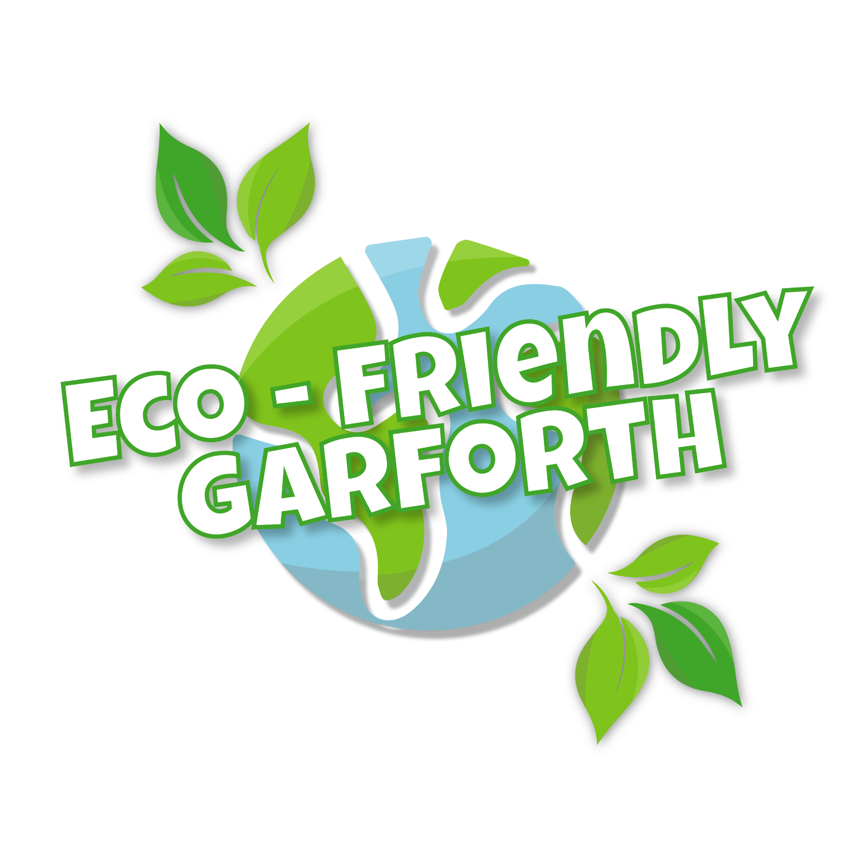
Eco-Friendly Garforth year 1 plan (draft)

Eco-Friendly Garforth tasks, structure and participation

Key tasks
Between February and July 2021, in the run up to opening a Garforth climate action hub in the late summer/ early Autumn of 2021, we have been working as an informal group on four key areas:
1) consolidating the embryonic group, into a democratic, inclusive and locally led climate action group
2) developing a climate action plan including selecting some key themes and activities and developing strategies for these;
3) exploring options for a hub or series of hubs in Garforth and work out a plan for how the hub(s) will operate (including how the worker will be recruited and employed)
4) raising awareness and reaching out to more people in Garforth

Group values
The following group values were initially drafted in May 2021 and amended in July 2021:

- Belief in change: embracing the realities of climate change can be overwhelming. We are choosing to emphasise the positive things that we can all do.
- Respect and tolerance: we are composed of different groups and individuals with different priorities but all passionate about the environment. We may disagree, but we endeavour to tolerate and respect differences. This will require us to develop and agree some clear boundaries around what we do or don’t get involved in.
- Collaboration and coordination creates a synergy. We are stronger and more effective when we bring our different strengths together and coordinate action
- Inclusion and diversity: we are open to involvement of anyone local to Garforth. We endeavour to take into account the views of anyone who gets involved or feeds in ideas.

Way of working
In March we agreed to work with an organising and decision-making model of sociocratic circles. This basically meant that we began organising with a main circle with the aim of ensuring that Garforth has a local climate action plan for activities and operation of its hub. This circle or committee has been connected to a series of sub-circles or working groups that were formed according to interest and direction.
Sub-circles are thematic based (so far we have an active travel group, an education group and a biodiversity group); or focused around a particular area of work such as outreach and events, comms or partnerships. Anyone involved in Eco-Friendly Garforth is invited to join the main circle, and/or initiate or join an existing sub-circle. The subsidiary circles and the main circle are connected by delegates who attend both the subsidiary circle meetings and the main circle meetings and can therefore transfer information back and forth. Each circle or sub circle has someone who steps up to be a circle lead, initiating meetings and setting agendas; a circle facilitator and a circle minute-taker, although sometimes some of these roles are combined and may be swapped at each meeting.

We are in the process of reviewing our way of working as we come to the end of this first phase. Going forward (once our plan is agreed and our worker recruited), we will be forming a supervision group to oversee the workers’ tasks. This will initially be composed of up to 3 members of Eco-Friendly Garforth at a time, the development worker for Garforth and one staff member from the employing organisation LS14 Trust. If more than three members of Eco-Friendly Garforth want to take on this supervisory role in the first year, we will agree on a timeframe and process for rotating in and out.

Participation
In the period February-July 2021
- Roughly 40 people have come forward to attend at least one meeting or asked to be kept informed about what is going on.
- 15 people have been involved consistently
- A handful more have continued to be involved occasionally.
- Our youngest attender has been 5, several 17-25 yr olds have been involved, as well as young professionals and retired people, parents, grandparents, people in Garforth but also Woodlesford, and initially Micklefield and Crossgates.
- We have a mixture of long term residents, people who have recently moved to Garforth and people who have left and returned.

Eco-Friendly Garforth is a loose coalition of individuals but also community groups. Garforth community greening group, Garforth Flood Management Group, Garforth community allotments, Garforth neighbourhood plan and Garforth hedgehogs and the various churches in Garforth all have several members who participate in Eco-Friendly Garforth. Other groups and businesses such as Garforth Incredible Edible, Garforth Wombles, Garforth Tigers, Oaktree Sustainability, Real Living Homes and Refill and Go stay informed from the sidelines whilst focussing on their own activities. There is a potential to build on these relationships as we move into a phase of action.

Employing organisation
LS14 Trust has agreed in good faith to be the local host organisation. LS14 Trust’s Trustees have approved the decision and arrangements are being negotiated in preparation for signing a partnership agreement once Eco-Friendly Garforth’s plan is approved.
LS14 Trust is a Seacroft-based community organisation based in a row of shops on Kentmere Avenue, located between Kentmere Community Centre & St Richard’s Church, over the road from the top end of Rein Park. Established in 2009 by local residents it now has a 1,000 strong membership base. For more information about LS14 Trust click here: http://www.ls14trust.org/about-us1.html

LS14 Trust is a registered charitable company with five Trustees, 10 employees and an income of £256,500 March 2019-20. It’s core charitable purpose is: ‘to develop the capacity and skills of the members of the socially & economically disadvantaged community of LS14 (Seacroft, Swarcliffe & Whinmoor (in such a way that they are better able to identify, and help meet, their needs & to participate more fully in society.’

LS14 Trust is already taking on this role for the Seacroft Climate Action group. Despite exploring more local options for the local host organisation, this has proved our only available option for now as other local organisations were not in a position to take the role on. It will be beneficial to work with a local host organisation that is achieving more of an economy of scale by administering two budgets and supervising two workers. We don’t expect to use their building for working space unless the Garforth worker was keen to work alongside a colleague, and we don’t expect them to be involved in the content of the group’s work. However, they will be a reliable, competent and supportive organisation for the administrative tasks and an independent party to go to for any concerns the worker may have about their work with and for the local group.
Recruitment for the Eco-Friendly Garforth worker will begin over the summer, with the need to coordinate with the Seacroft worker’s recruitment. Eco-Friendly Garforth hopes that the worker would be in place in late September/ early October but this is still to be agreed.
Initial plans for the hub
We have explored a number of options for the location of a physical climate action hub and opted for a scenario involving a regular location where the worker will be placed for about 2 hours a week where people can drop in, enjoy a cuppa and found out what is going on; an online hub (website and social media pages) which will be kept up to date by the worker and a series of events and meetings hosted in and around Garforth in different outdoor and indoor venues.
We are still waiting to hear back from some venues about availability and cost for the regular drop-in venue but currently we have quotes of £18-36ppw. We are still hoping that we might be offered a free or discounted space somewhere.

Year 1 Plan
There are lots of ideas that have been proposed on the Garforth climate action plan Ideasboard which was contributed to by a variety of people, some of whom are actively involved in Eco-Friendly Garforth and others not. This shows some scope of what may happen over the next years in Garforth. In the short term, those who are active in the group have chosen the following priority areas:

- Active Travel
- Biodiversity and Nature
- Outreach and education

Other areas may emerge soon (such as energy and retrofit) once the hub is set up and the worker is in place but those involved in the group have already been splitting their attention in lots of directions.

Active Travel
Context:
An active travel sub circle has been meeting since April and has members who are passionate about walking and cycling. Parts of Garforth are quite well set up to be a 15 minute neighbourhood, with the Main Street providing both shops and doctor’s surgery. It is also well connected to Leeds by public transport. However there is lots of car use for short journeys to Main Street, to schools, for commuting, and to surrounding villages.
Action:
Short term:
- develop a walking map for Garforth to be published as a leaflet and online;
- organise a family cycling day along a local greenway;
- 2 month-long walk-cycle-scoot community challenge to collectively clock up as many miles as we can during September and October (see education and outreach).
- feeding into work with the local care partnership and active leeds to co-produce some active travel solutions with a grant available through these partners.

Medium term:
- campaign for more cycling storage and more benches on the way to Main Street,
- campaign for provisions for safe family cycling.
- campaign against a new car park, to campaign for an electric car hire scheme and to campaign for pedestrianisation of the Main Street or at least a reduction in traffic.

Nature and Biodiversity
Context:
This area is currently being led by a member of Eco-Friendly Garforth who founded Garforth Community Greening Group in Spring 2020 just before lockdown. The majority of the ideas come from scoping work that was done by that group before Eco-Friendly Garforth formed. The group was already collaborating with Garforth Hedgehogs and a couple of other green groups in Garforth. Since members of Garforth Hedgehogs and Garforth Community Greening Group joined Eco-Friendly Garforth, it made sense to do this work through Eco-Friendly Garforth and within the Garforth climate action plan.

Action:
Some action is already underway such as the pond project at a local primary school, by Garforth Community Greening Group, and a wildlife area co-managed by a coalition of green groups. The group would like to increase ponds, wildlife areas and meadow sites in Garforth, and organise large-scale tree planting (see table at the end of this document).

Outreach and education
Context:
During the initial phase of Eco-Friendly Garforth the group has been trying to balance the need to consolidate and meet initial requirements to release funding, whilst being low on capacity to develop lots of actions. The need for outreach has been identified- both to include more people in the group and to organise large-scale events and actions that serve to educate people. The comms sub circle, events sub circle and education sub circle are all thinking about this overarching area. Social media and virtual presence is going to be important for this, as well as in person events within covid limitations. The group has done as much as possible pre-release of budget but is keen to get going on a number of things as soon as we have the go-ahead.
Action:
Already completed:
- Developed a logo, bio and slogan for the group and has set up a facebook, instagram and draft website (will be a key part of the operation of the virtual hub)
Awaiting release of budget:
- purchase a domain name and finalise the website.
- Upkeep social media and website (primarily by hub worker)

The group would like to have a presence at as many local events as possible to reach a wide audience. We are doing a stall at Breeze over the summer holidays, and hope to be at Garforth Feastival (food festival), on Main Street during the Big Green Week in September and at Garforth Bonfire night and Christmas light switch on. In order to be well set up for these stalls, the group would like to invest in materials such as a gazebo, table and boards. In the meantime these are being borrowed.

In terms of events, we are planning a walking-cycling collective clock-up-the-miles event during the Big Green Week where we raise people’s awareness about COP 26 in Glasgow and the need to act locally, by trying to cover the distance of Glasgow and back within and around Garforth, multiple times over. We are planning to get schools, local cycling clubs, families and individuals involved. We are applying for a grant from the Yorkshire Sport Foundation to help fund this.

There are also ideas to host an ethical fashion show in collaboration with charity shops, a make and mend event in collaboration with the cobbler and the embryonic repair cafe, and a local makers fair (or at least have their produce on a stall of our own).

In terms of education, the education sub circle has been working on a recycling map to educate people about what and where they can recycle, and is planning a campaign to encourage parents to turn off engines when dropping children off at school.

Figure: summary of how Eco-Friendly Garforth functions with a Main Circle, Sub Circles and in collaboration with existing community groups (shown with large arrows). The existing groups depicted are just a selection, chosen to show how the biodiversity group sits in the middle of Eco-Friendly Garforth, Garforth Hedgehogs, Garforth Flood Management Group and Garforth Community Greening Group.

Eco-Friendly Garforth

Active Travel

Events
Comms

Main circle

Garforth Community Greening Group

Garforth Hedgehogs
Biodiversity

Hub details (likely to evolve into hub worker supervision)

Garforth Flood Management Group

Education

Preliminary budget ideas

Most of our budget working-out has not yet been done but we have just listed the items the group is already ready to spend money on as these things will help us to reach out and get more people involved. We haven’t yet gone through a decision-making process within the group for approving costs related to these or other areas of action but would do this before any money is spent..
Budget line | Details | Estimated cost | Responsible
Purchase of domain name and hosting | Enabling us to have our own domain on a basic website, and an official email contact | £3/month | Comms sub circle
Stall hire costs | 4-8 per year | TBC | Comms sub circle
Printing of logo on banners, Hi Viz jackets and business cards | Helping to get the group known during events | TBC | Comms sub circle
Stall set up materials | Gazebo, table, boards | TBC | Comms & events sub circles
Printing | E.g. walks leaflet, recycling map | TBC | Active travel sub circle
Expert fees | Pay for a consultant to give advice on wildlife areas | TBC | Biodiversity and nature sub circle
Liability insurance | To cover events and work in the wildlife area | TBC | Main Circle/ hub worker
Subsidy for retrofit training | Carbon Lite or Retrofit coordinator training- subsidise cost for first two local builders to get accredited? | £500? | Housing sub circle (not formed yet- this is just an idea)
Event, drop-in and meeting space hire | C.14-18 hours per month | TBC | Main Circle/ hub sub circle

Theme | AREAS OF ACTION – | Rough timeline and budget if known | MEASURES OF SUCCESS | CAMPAIGNS | Rough timeline and budget if known | MEASURES OF SUCCESS
Nature/ Biodiversity (N/BD)  Walt, Greening Garforth and Garforth Hedgehogs | Ecologist to advise on the potential of sites in Garforth and where maximum benefit can be found: (1) Garforth Wildlife Area (2) Hawks Nest Wood (3) Fire Station tree / meadow area (4) Brierlands Fold | ASAP (but may need visits across the year) | * We have the information we need to prioritise and create a plan for enhancing biodiversity in Garforth.  * We have increased collective knowledge on how to assess and begin to look at other areas.
N/BD | Garforth Wildlife Area | Work is already well underway but following an ecologist review this is likely to be the first area to focus on.  (Concerns to address on the liability insurance cover if working on site) | * We could do with having a diversity audit and then follow this up in a year or so to see how it has improved.  * Members have enhanced skills in managing wilder areas.
N/BD | Strawberry Fields Pond area |  | In regular use by the school. Demonstrated by the materials the children create.
N/BD | Tree planting: Need target list. So far we have Makins tree corridor (but that maybe be a hard nut to crack due to local “politics”. Garforth Hilton - needs an approach. |  | * land identified to plant on and permission granted.  * trees planted and thriving  * biodiversity demonstrated to improve | Treebilee – 5,000 trees for Garforth  (Green Burial Ground?) |  | (1) Land identified where trees can be planted  (2) 1,000 planted this year?
N/BD | Meadowing sites (1) East Garforth School (2) Strawberry Fields (3) Brierlands Fold (4) others | using Network Rail budget? |  | Re Meadows for bio diversity  LCC relaxed mowing.
N/BD | “Ponds” not sure where to take this yet whether increasing in people gardens or take inspiration from Milton Keynes
Education  Brian, Jade | Produce online and paper map of recycling facilities in Garforth  Gather user friendly information resources re climate change? | Draft map already produced; needs checking and finalising. Would be put online with a small no. of printed copies- minimal cost. | Map online and copies available at events, in The Hub and possibly at shops on Main St. | To switch engines off when idling/stationery  Reduce car use on school journeys | Need to contact schools to determine level of support for a campaign; time determined by schools- minimal costs as lots of resources on line.  Reducing car journeys to be considered for spring as weather improves. | Significant reduction in idling cars counted outside schools compared to pre campaign assessment.
Transport and Active Travel  Jacky, Carol, Carla, Jennifer | Produce an online and paper resource of local walks  Work with LCP to promote Active travel  Family Cycling Day | Applying for some funding from Yorkshire Sport Foundation for a first cycling/ walking event |  | Provision for safe family cycling  For more benches on way to Main Street.
Moira, Jacky, Mark | Encourage local builders to get accreditation in retrofit technologies eg. AECB -Carbon Lite and Retrofit coordinator training. | Maybe offer to reimburse half the cost of the training, on successful completion of it, to the first two local builders to bring us certification? £500 |  | A lightbulb moment!  To achieve switch across homes & businesses to LED lighting. | Purchase some LED bulbs as prizes? £100 In addition seek a discount from PEASE on these for week/month of campaign.
WORK & ECONOMY | Find ways to support growth of green jobs & apprenticeships in Garforth.  Find ways to work with and support existing low-carbon enterprises in Garforth |  |  | For retrofit qualification training at Leeds Building College?
ENERGY  Walt | Still to be worked out |  | Can we get data on energy use across Garforth?

